ENGG1340 Computer Programming II Module 0

Ng Ho Lam (3035687649) ElecE Yr 2

Task 1:

CS Username is h3568764.

Task 2:

X2GO

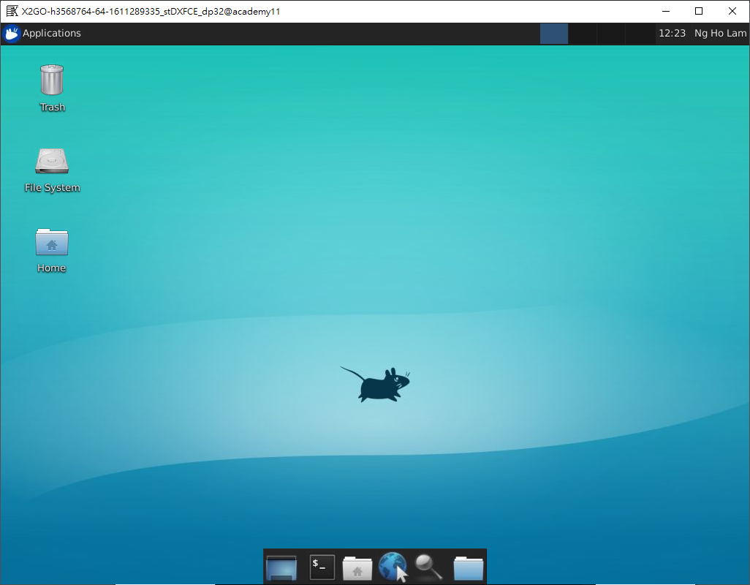

SSH:

I am able to observe the terminal print out the day of week, the current month and day, the current Hong Kong Time and the year 2021 after inputting “date”. “Fri Jan 22 12:27:09 HKT 2021” to be exact.

SFTP:  
